**REDIS SESSION GUARD SERVER OVER NODEJS**

FIRST WE INSTALL REDIS SERVER IN UBUNTU XENIAL:

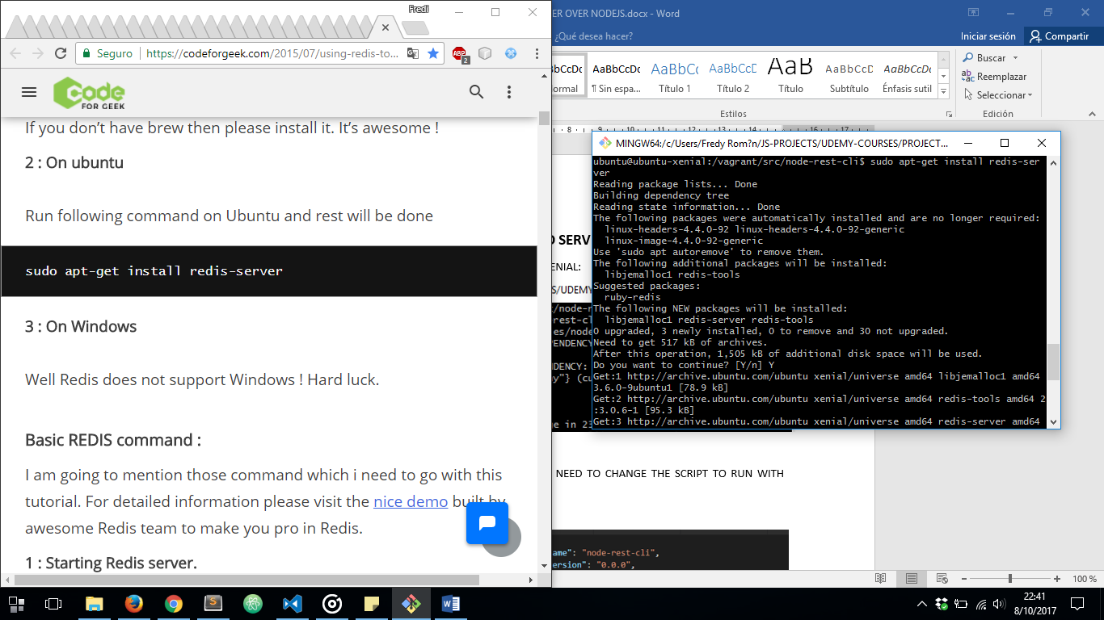

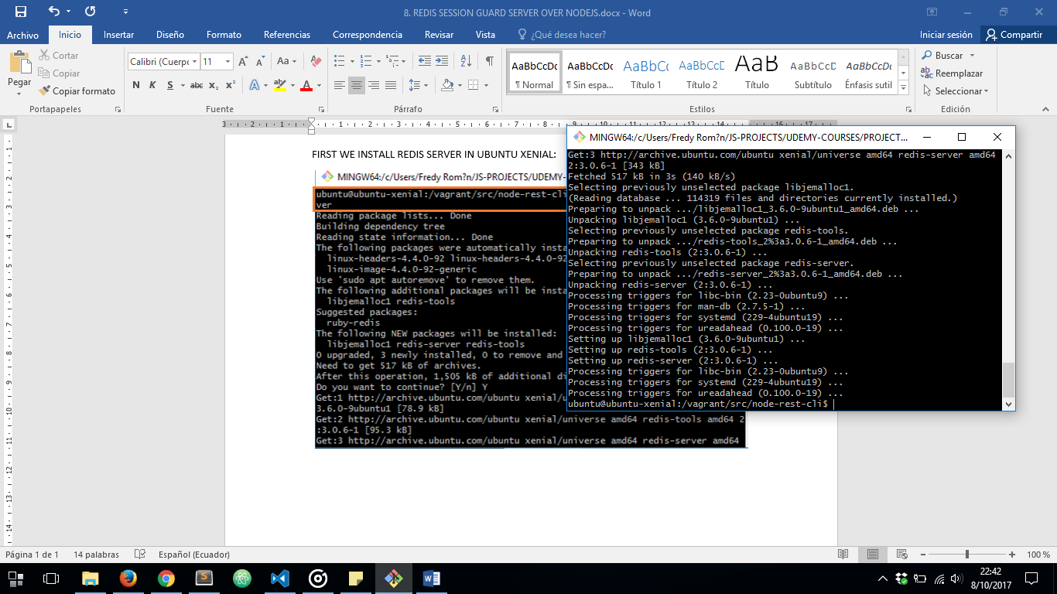

THEN WE START REDIS SERVER USING NEXT COMMAND: ***redis-server &***

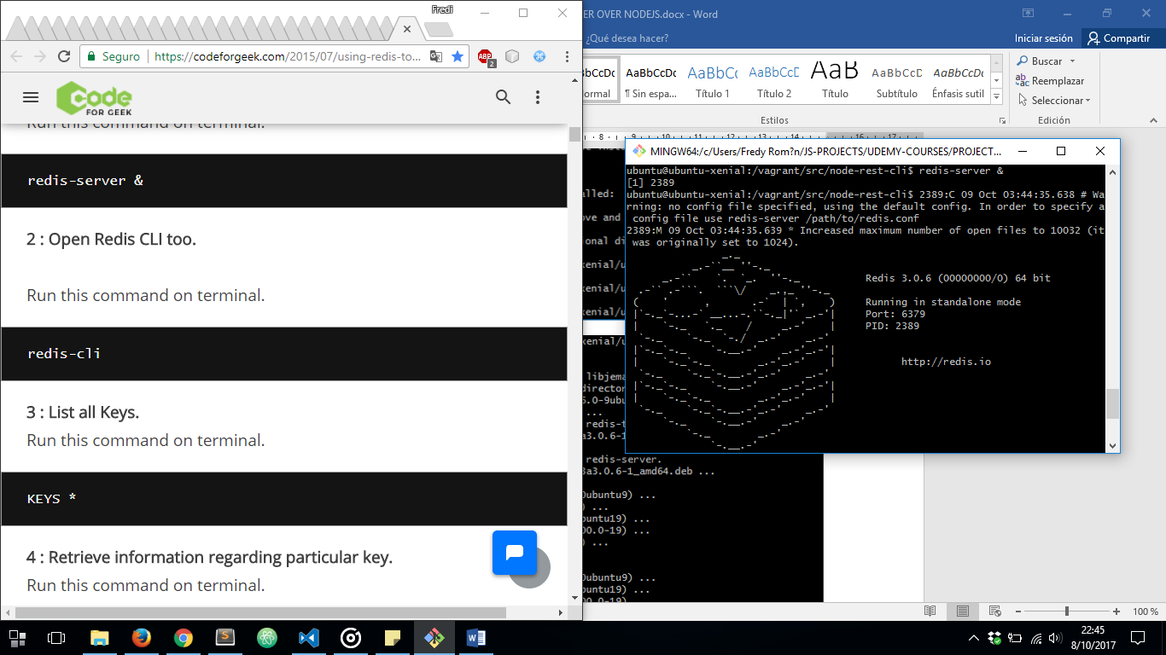

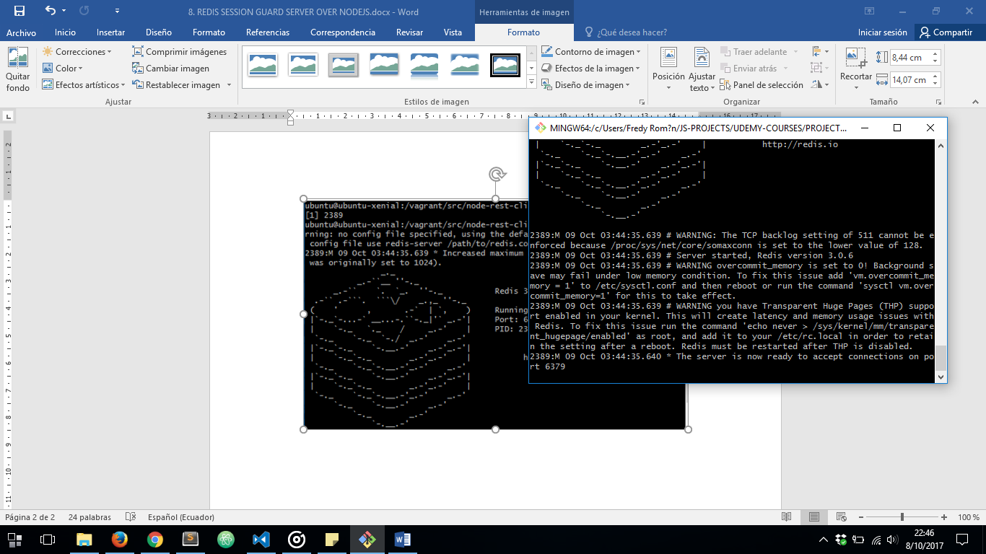

ONCE REDIS SERVER INSTALLED, WE NEED TO INSTALL SOME DEPENDECIES IN OUR NODEJS SERVER:

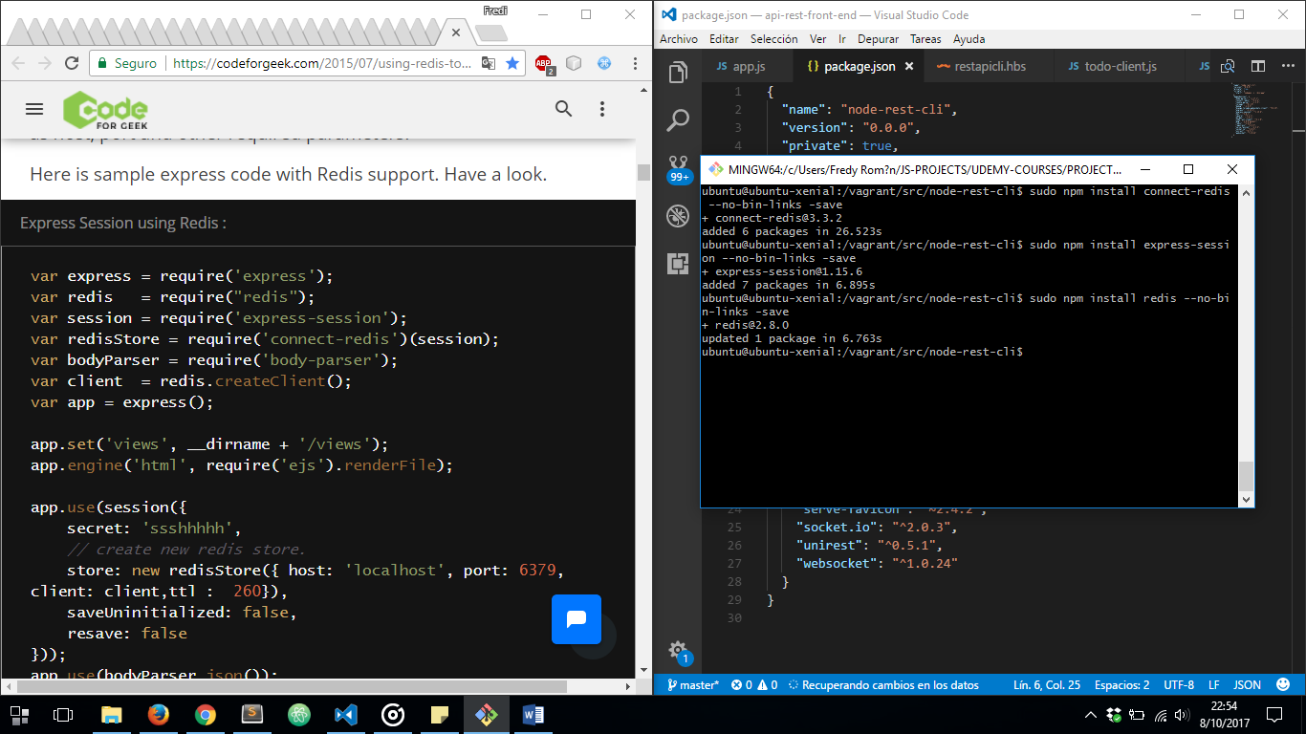

THEN WE HAVE TO MAKE SOME CONFIGURATION CHANGES IN OUR ***app.js*** EXPRESS GENERATOR MAIN FILE TO ENSURE SESSION STORE ON REDIS SERVER:

IMPORTING MODULES:

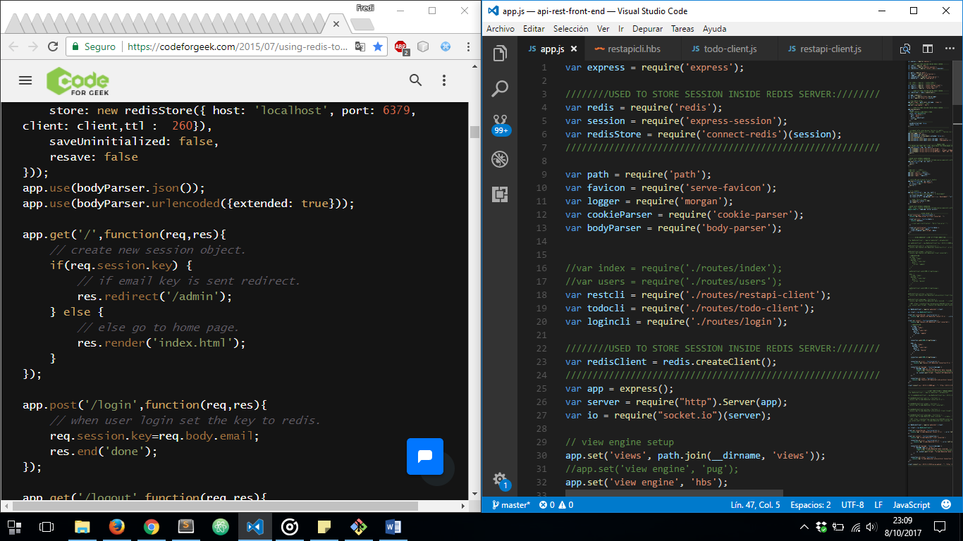

CREATING NEW SERVER CLIENT:

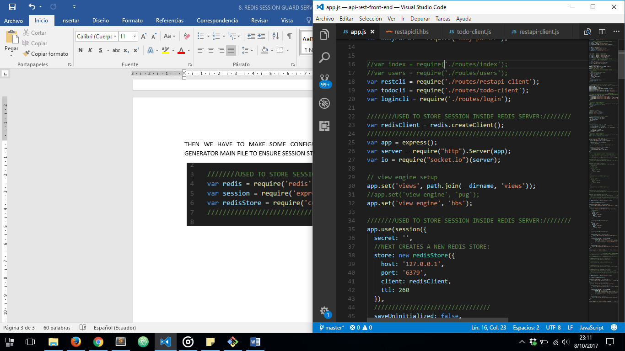

CONFIGURING OUR DATA STORE OVER REDIS:

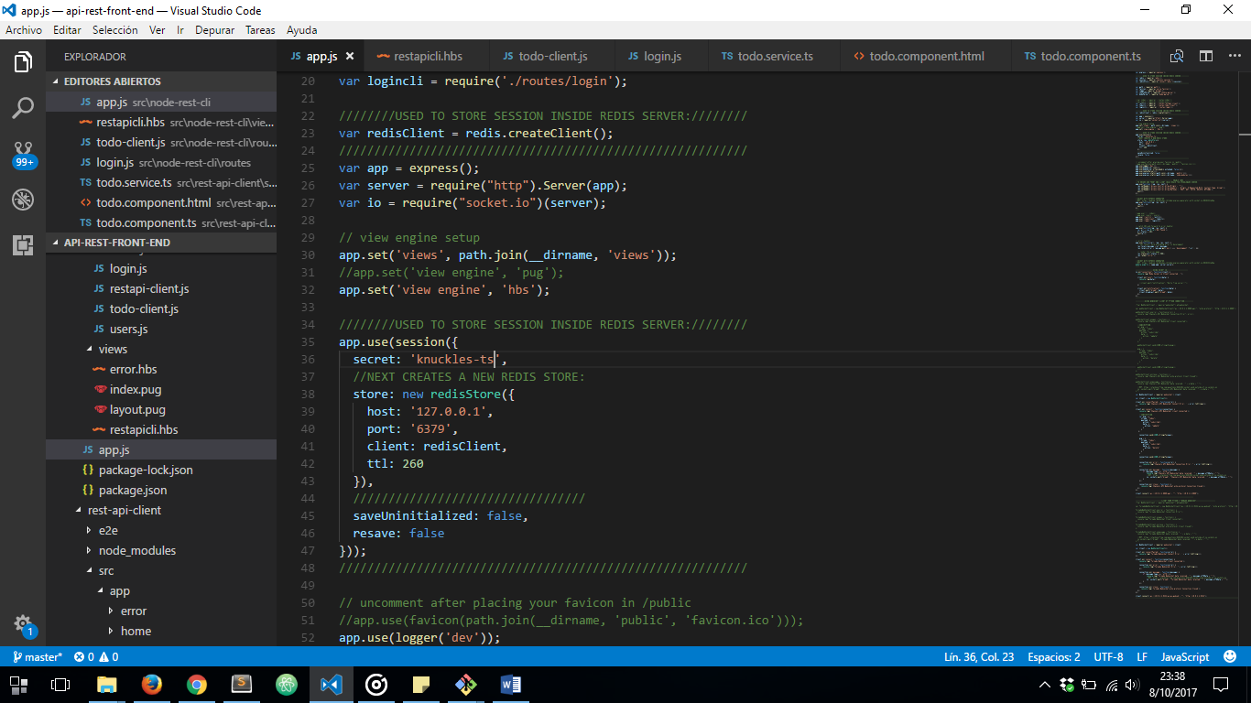

AND THEN CAN STORE IN OUR REDIS SERVER SESSIONS GENERATED WITH EXPRESS:

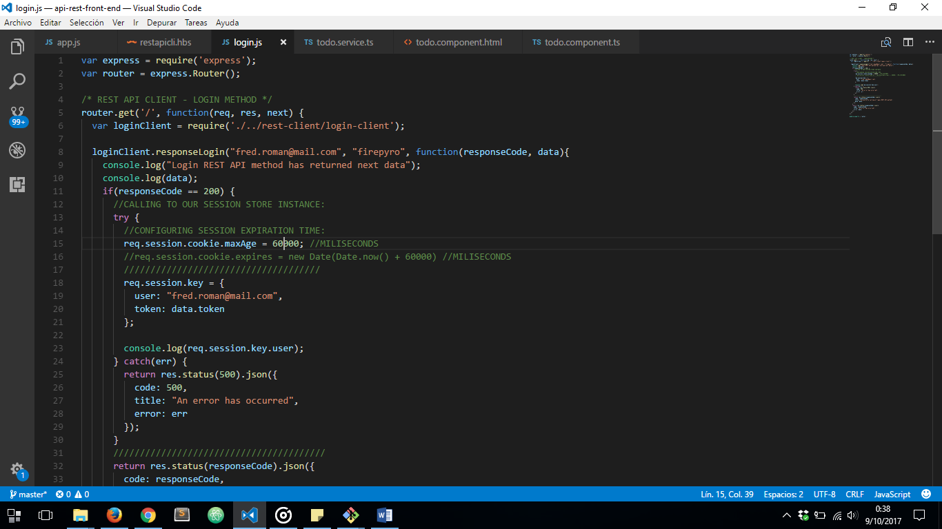

IF WE VERIFY ON REDIS SERVER:

